**Final Project Report**

**Results**

Results when you run your own test program, e.g., explain what additional testing you did, how and why.

For the most part we were able to successfully run the system calls for the same data within the same test file (test5). Test5 confirmed that our file system calls work for big and small files works for our file system. You can see the results in figure 1 below.

If we look at the outputs, I got for test 6 in the figure below, we can see that almost all tests were successful except test 18. Test 18 tests the behavior of the parent and child reading from the same file and reading from the file using two independent file descriptors. I tried to see what the issue was by first figuring out why the size was -1 for Test6.java but was unsuccessful. But a theory I have is that Test6.java was not reading the right file created from Test5.java.

**Figure 1 – Test5 Outputs**

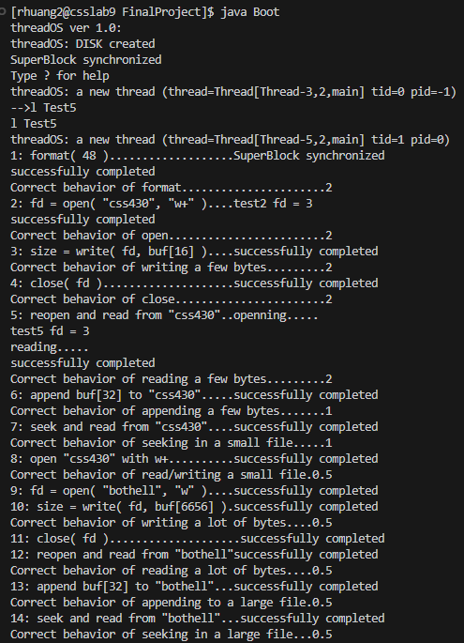

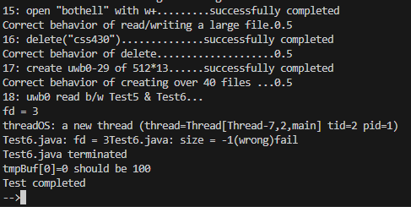

I didn’t do much additional testing as it took me a while just to finish the project as I am working alone. I did, however, add some print statements throughout my program to test and debug. Those statements are not included in my output in Figure 1 as it takes up too much space. I also commented them out throughout the program too. I left them there for further testing purposes in the future.

**File System Specifications**

Your file system specification, including your assumptions and limitations.

* System calls that can be made is:
  1. Format, open, close, read, write, seek, close, delete, and fsize.
  2. We assume you are only going to do these system calls through SysLib.
* Modes allowed is:
  1. r (read), w (write), w+ (read and write), and a (append)
  2. we assume that you will use the same abbreviations to indicate the modes.
* Limitations
  1. We have one single level root directory only.
  2. Disk contains 1000 blocks each with 512 bytes.
  3. We have only one indirect block which points to an indirect index.
     1. The indirect index has 256 indexes.

**Design Description**

Descriptions on internal design including inode, file table, etc.

In Figure 2, we can see the big picture of the file system. To get files from a disk a thread must put in a file table entry in the file table. Even though it is not shown, the directory is located in the file table. The directory contains all a directory entry which contains a file. The directory entry contains the file name and the inode number that corresponds with the file. Using the inode number we can find the file from the inode table as shown. The first block of the inode table is the superblock. The superblock is an important block that contains all the inode information such as the total number blocks in the disk and the number of inode currently in the inode table. The free list is one of the most important as it contains the number of heads of free blocks that we can use to allocate files.

Each inode block has 16 inode. Each inode has 11 direct and 1 indirect block. These blocks are what points to data in the disk in which we can access. In the disk, each block is 512 bytes, and we assume there are 1000 blocks in the disk overall. A more thorough descriptions of the classes and what it does and contain is described in the implementation header comments.

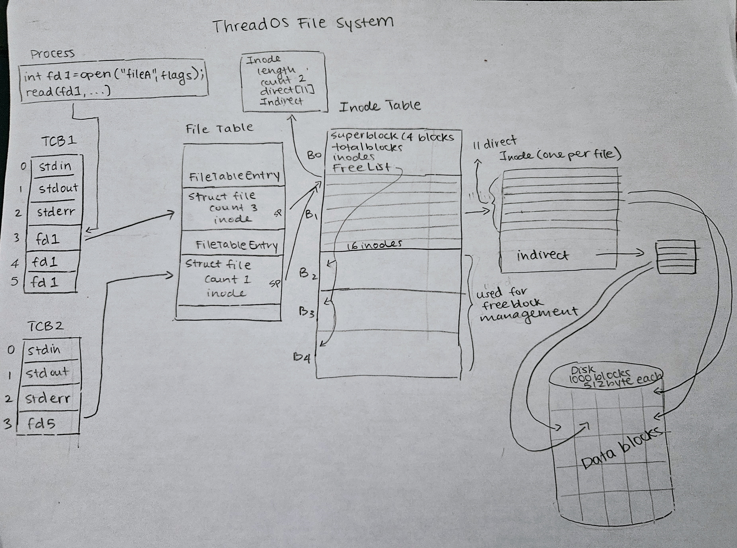

**Figure 2 – File System Big Picture (References from in Assignment Notes)**

In figure 3, we can see how all the classes are linked. This UML diagram is referenced from the implementation map from the assignment notes. The Kernel is what initiates the system calls and SysLib is the one sending those system calls to Kernel. The File System itself is contained in the Kernel which contains a SuperBlock, Directory and FileTable. The FileTable contains the FileTableEntry, which is what the threads input to get access to the file. The inodes can inode table which is referenced in the file system but not explicitly shown. The directory is also in the FileTable.

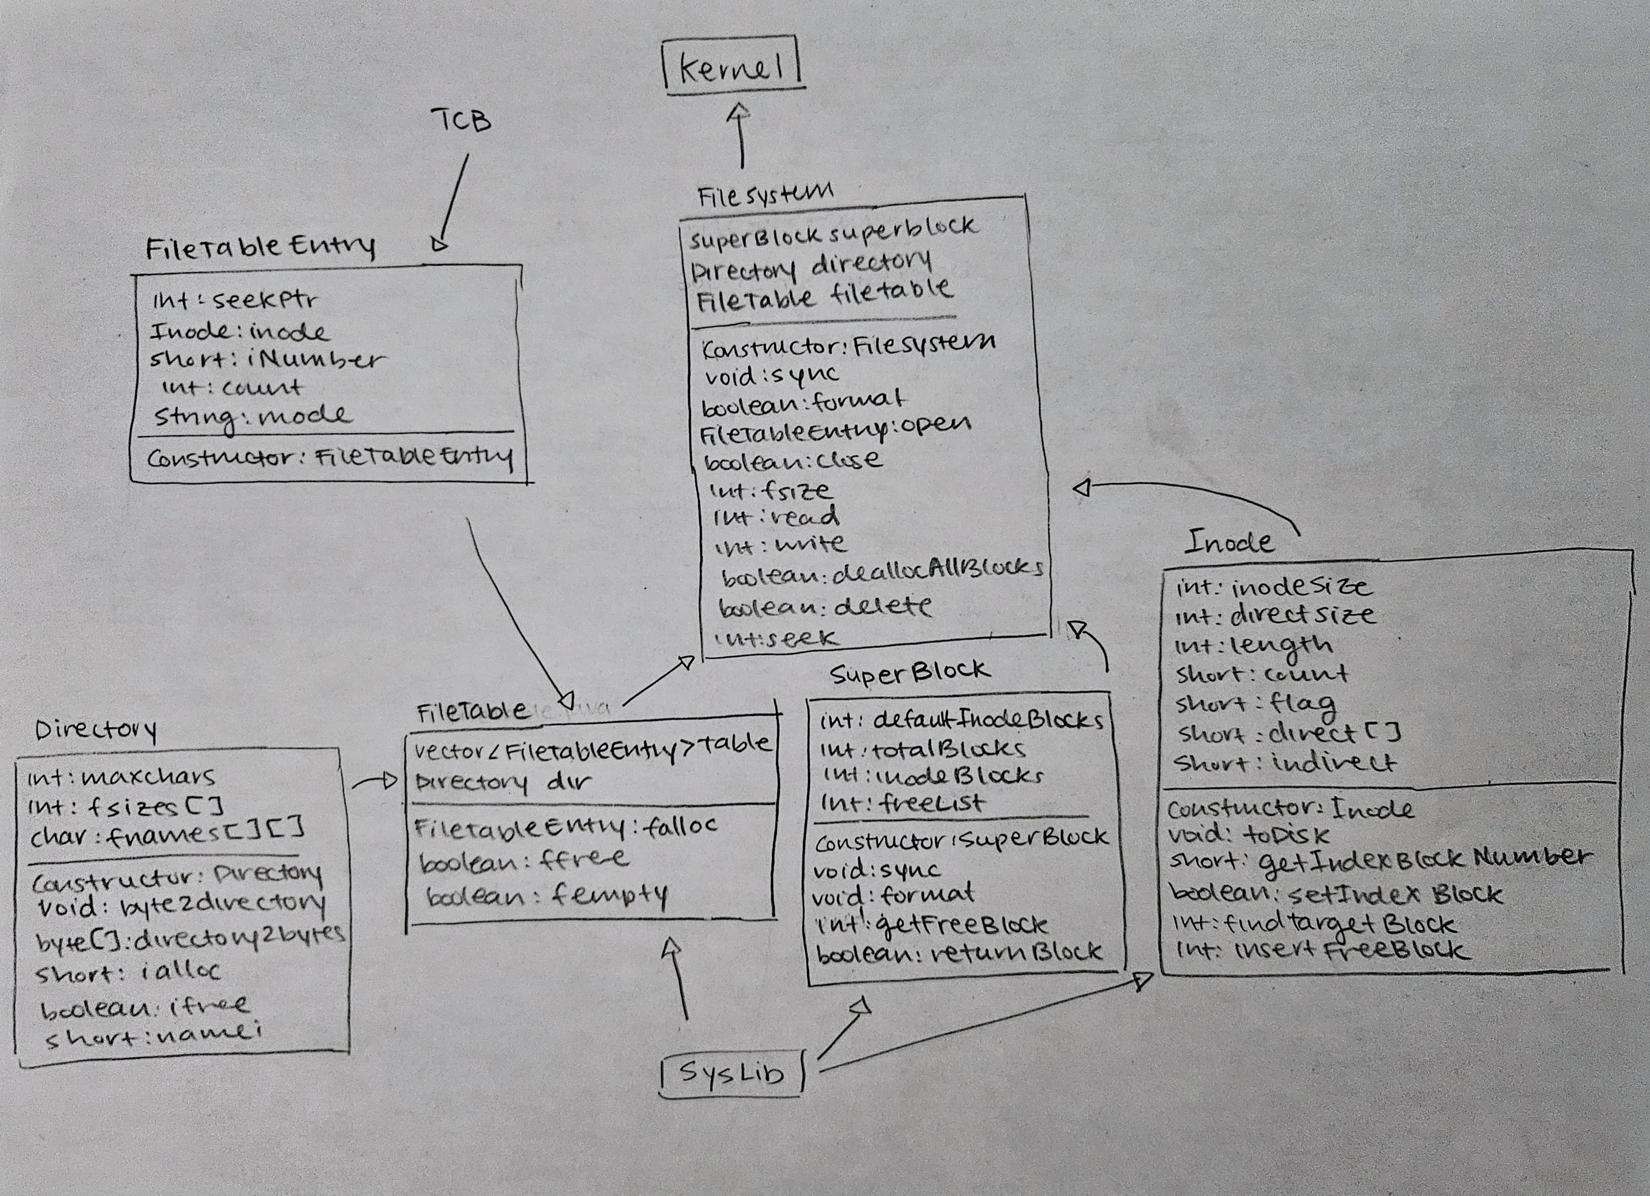

**Figure 3 – UML Diagram (referenced from Implementation Map in Assignment notes)**

**Performance and Functionalities Considerations**

Consideration on performance estimation, current functionality, and possible extended functionality,

The performance of the file system is fast when it comes to dealing with smaller files. When it comes to larger files it takes much longer. For example, for our test 5, when we had to read or write a larger file it takes around 20 seconds for it to be fully done but it only takes less than 5 seconds for a smaller file. A possible way to better the performance is adding the cache we created from our program 4J. Some other ways are to change the way we access the files or maybe try a different allocation method like contiguous allocation (need less seeking time and therefore better performance). It is important to note that we are currently using the index allocation method. The performance of index allocation depends on if our file is located in a direct block or the indirect index because accessing an indirect index block takes more time than directly accessing the file from a direct block.

Right now, you can only do the system calls such as format, open, read, write, seek, close, delete, and get the size of the file using fsize. Some other functionalities we can add is being able to make a copy of the files, check who have written to the file, change the file location or choose where to put the file in the directory, see the contents of the file using one command, and more. There are a lot more functionalities we can add, we can look at Linux’s file system as reference.